# How to pass and return object from a function in C++?

In C++ programming, objects can be passed to a function in a similar way as structures.

## How to pass objects to a function?

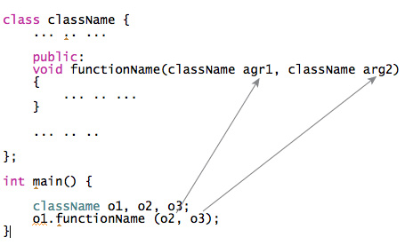

## Example 1: Pass Objects to Function

**C++ program to add two complex numbers by passing objects to a function.**

#include <iostream>

using namespace std;

class Complex

{

private:

int real;

int imag;

public:

Complex(): real(0), imag(0) { }

void readData()

{

cout << "Enter real and imaginary number respectively:"<<endl;

cin >> real >> imag;

}

void addComplexNumbers(Complex comp1, Complex comp2)

{

// real represents the real data of object c3 because this function is called using code c3.add(c1,c2);

real=comp1.real+comp2.real;

// imag represents the imag data of object c3 because this function is called using code c3.add(c1,c2);

imag=comp1.imag+comp2.imag;

}

void displaySum()

{

cout << "Sum = " << real<< "+" << imag << "i";

}

};

int main()

{

Complex c1,c2,c3;

c1.readData();

c2.readData();

c3.addComplexNumbers(c1, c2);

c3.displaySum();

return 0;

}

**Output**

Enter real and imaginary number respectively:

2

4

Enter real and imaginary number respectively:

-3

4

Sum = -1+8i

## How to return an object from the function?

In C++ programming, object can be returned from a function in a similar way as structures.

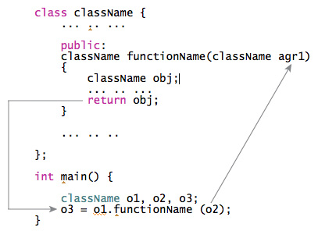

## Example 2: Pass and Return Object from the Function

In this program, the sum of complex numbers (object) is returned to the main() function and displayed.

#include <iostream>

using namespace std;

class Complex

{

private:

int real;

int imag;

public:

Complex(): real(0), imag(0) { }

void readData()

{

cout << "Enter real and imaginary number respectively:"<<endl;

cin >> real >> imag;

}

Complex addComplexNumbers(Complex comp2)

{

Complex temp;

// real represents the real data of object c3 because this function is called using code c3.add(c1,c2);

temp.real = real+comp2.real;

// imag represents the imag data of object c3 because this function is called using code c3.add(c1,c2);

temp.imag = imag+comp2.imag;

return temp;

}

void displayData()

{

cout << "Sum = " << real << "+" << imag << "i";

}

};

int main()

{

Complex c1, c2, c3;

c1.readData();

c2.readData();

c3 = c1.addComplexNumbers(c2);

c3.displayData();

return 0;

}